Your Community Safety Information Pack
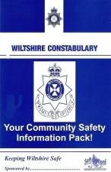

Before any Start-up Meeting the NPT will request NHW packs for all scheme members.
This page shows the documents that will be placed in the pack.
Nhw pack contents
Contact sheet (NHW06
2. Community Action Against Crime (HO)
3. Be Safe, Be Secure (HO Leaflet)
4. Incident Report form (HO
5. Stay Out Stranger (Wilts Leaflet)
6. Peace of Mind (HO)
7. Contacting Wiltshire Police (Wilts)
8. Coded for Keeps (HO)
9. NHW Sticker (HO)
Packs can be obtained on reqest to David Budd

